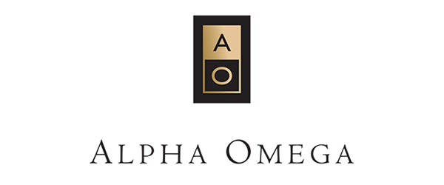
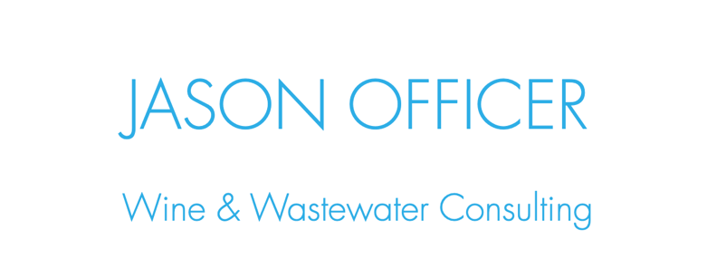

"My primary interest in both the wine and wastewater industries is the marriage of the two worlds. I am passionate about the maintenance and management of all operations, troubleshooting obstacles and implementing solutions to create a smooth and streamlined process for all."

Some of the sustainability efforts that I am focused on for Alpha Omega's Wastewater Treatment Plant (WWTP) are:
- analyzing flows coming into the WWTP to assist the winemaking team with tightening necessary water usage
- adjusting pump and blower speeds to optimize electrical efficiency while maintaining the best possible biological health for BOD digestion
- regular health checks, calibrations, and preventive maintenance to secure continued effectiveness of the WWTP

All of this is necessary to ensure pond water that is within regulatory requirements to be sent to the vineyards to complete the water cycle in saving every drop possible.

Jason Officer
Wine & Wastewater Consultant
Jason Officer Consulting LLC
707-501-8098
JasonOfficerConsulting@gmail.com
OfficerWines.com

